|  |
| --- |
| Digital Ordering Suggestive Selling Guide v1.0 |
| Improving Guest Ticket Average for Digital Channels |
|  |
| This guide will help markets design a suggestive selling flow that will help generate multiple sales out of a single opportunity |
|  |

Digital Ordering Suggestive Selling Guide v1.0

Improving Guest Ticket Average for Digital Channels

# Psychology of Suggestive Sell

• • •

We experience a degree of pain when giving up our hard earned cash, whether it is for something we need, or something we‘d merely like to have. This concept is known as the “Pain of Paying.” Credit cards actually help anesthetize the pain as it doesn’t feel like we are parting with money. Casinos also mask this pain by using plastic tokens instead of cash.

Customers also experience a diminishing sensitivity to this pain as lower priced, complimentary products are offered at the right time and the customer perceives the value of the products. In other words, adding fries to an order hurts less than the initial pain of buying the burger.

# A Distinct Advantage

Online ordering is being widely adopted by Yum! markets due to three primary advantages:

* Customer satisfaction is higher with online orders
* Online orders cost less to process vs a phone order
* Guest Ticket Averages are higher with online channels

The higher ticket average comes from two primary reasons. Customers shopping online can do so at their own pace without any pressure to hurry. This allows them to browse more menu items and customers often add more items to their cart. Another reason is the consistent use of suggestive selling in online channels. It is very difficult to consistently execute on suggestive selling offers in a call center environment during our peak hours. A web system executes 100% of the time.

Markets that do not take advantage of this are missing the opportunity to maximize the results of a single transaction.

# How to Use This Guide

The principles listed in this document are intended to be used by marketing teams with their online and mobile ordering suppliers to supplement current order flows. We recommend a design workshop is conducted to align on how the systems can be modified. If possible, the system should be deployed in limited production environment to allow comparison between a set of control stores to gauge the lift.

# Principle #1: The Right Offer

The primary driver for a successful suggestive sell is offering the customer something that is truly going to benefit the customer. We must offer the customer something that the customer is interested in (or at least receptive to). It should clearly relate to the business at hand and must be “situationally appropriate.” An example of an inappropriate suggestion for our business would be dessert for during a breakfast window.

As a general rule, suggestive selling items should only be offered if they are less than half the price of the item being considered. Items which are more than 50% of the considered item have an extremely low attach rate. We should not suggest a higher priced item than the original considered item. Offering bundled products (or combos in our business) have a high level of success.

## Optimizing the Offer

Understanding the purpose of the purchase can greatly increase the relevance of what to offer. For our business, the number of people being fed is a key factor. Guest ticket size can be used as a proxy to understand the number of people being fed. Analysis performed by Pizza Hut US revealed that the more people are being fed, the higher the uptake of bundles that include both sides and wings. It also revealed that customers purchasing for one person are more likely to add a beverage. The insight from this analysis produced a set of rules that increased SSSG by 1.5%

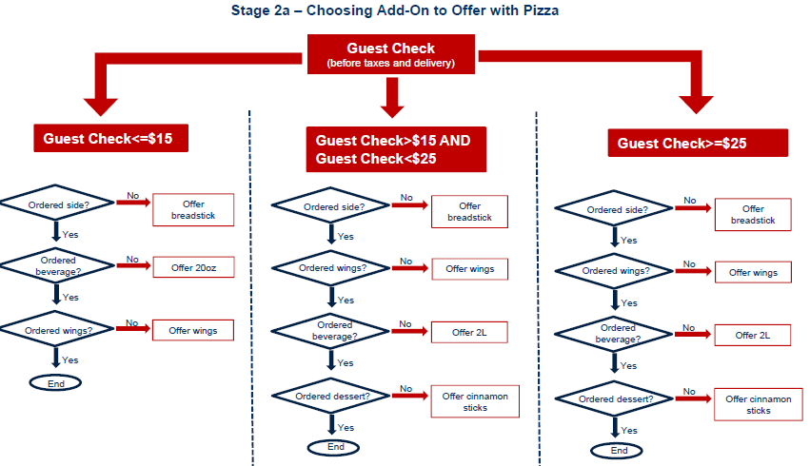

A similar simple set of rules should be developed for your market and brand.

# Principle #2: The Right Time

Suggestions can be presented in various parts of the user journey.

## Within Product Categories

Dedicated panels on a website can be used to deliver offers during the customer shopping experience. This may not be possible with mobile sites, but can be an effective way with websites.

### KFC Taiwan Example:

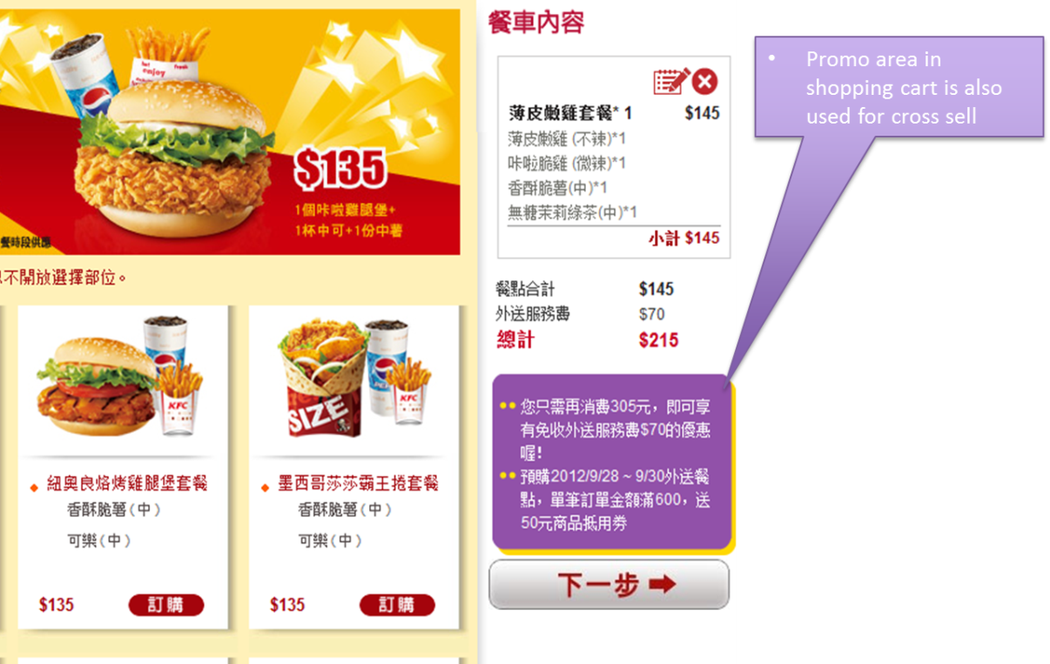

Pizza Hut US Example  
: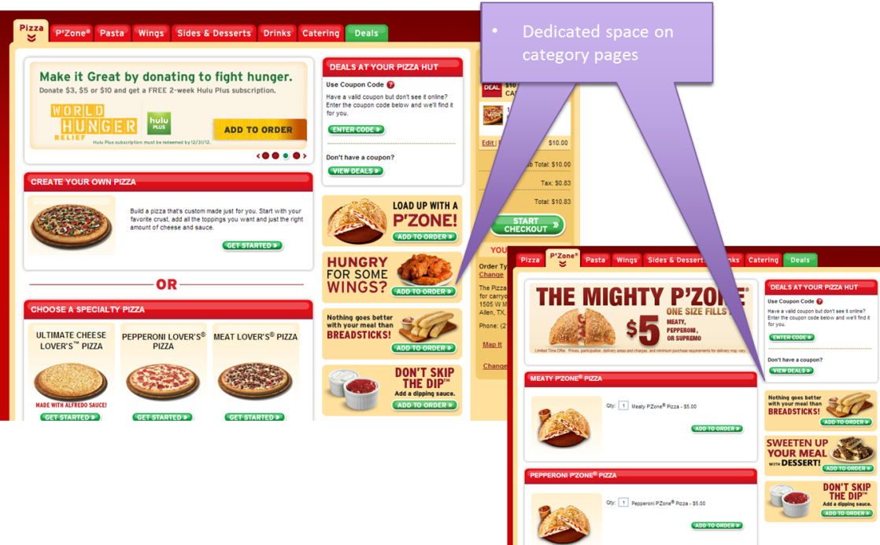

## When Adding to Cart

Many products lend themselves to complimentary products. As long as the offer is complementary to the product being added to the cart, customers will see it as a natural part of the flow. For KFC, this is perfect time to suggest a combo. For our pizza, it could be adding extra cheese.

The example below is very passive and is not really considered a suggestive sell. Their page merely allows for adding complimentary products on the same page as the sandwich.

### McDonalds Delivery Philippines

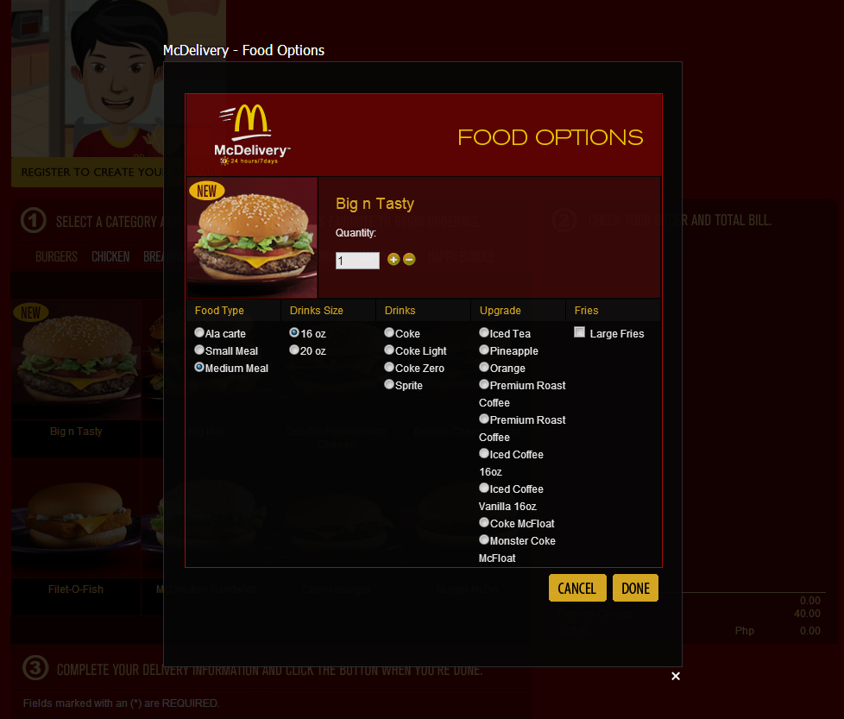

Consider an alternative approach from Burger King which actually suggests the combo after the customer adds the sandwich to the cart. The effect on the customer is more similar to that of actually being in the store conversing with someone behind the counter

Burger King Delivers Example

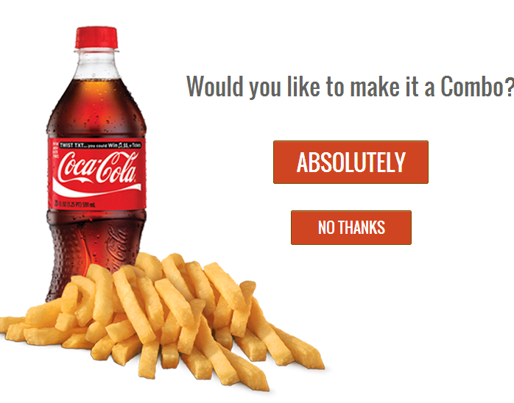

## Final Order Review

The most popular form of suggestive sell in our industry is upon beginning the checkout process. Concerns sometimes arise that this could distract a customer from a very critical moment in the purchase cycle. The distraction will be minimized so long as the offers presented are relevant and have value for the customer.

### Pizza Hut US Example

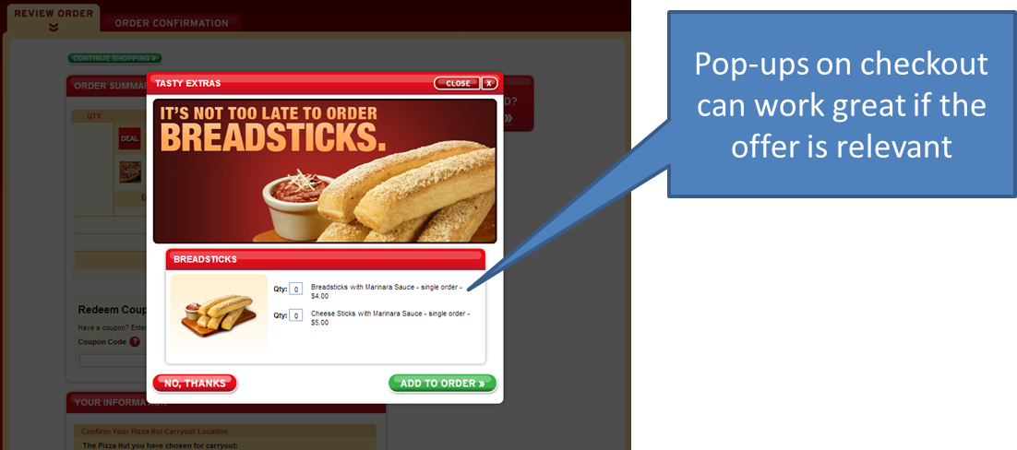

# Principle #3: Design is Critical

Everyone knows that businesses will usually try and sell them more. Suggestive selling is a percentage play; it will succeed a small portion of the time, but the successes should justify the effort. The design of the suggestion interface can increase the percentage of customers who will take the offer.

## Clear Call to Action

Use very clear language and visuals to encourage the desired option. The Pizza Hut US example above is a good example as it has everything a customer would need to make a decision, including price. The Burger King US example above has some great features including powerful wording like “Absolutely”, but is lacking the price.

## Defaults

Opting In/Out of an offer can be improved simply by emphasizing the desired option. Combined with a clear call to action, the customer should be able to quickly decide without any surprises. The Burger King US example uses a great technique to have a dominant affirmative button.

### Subway US Example

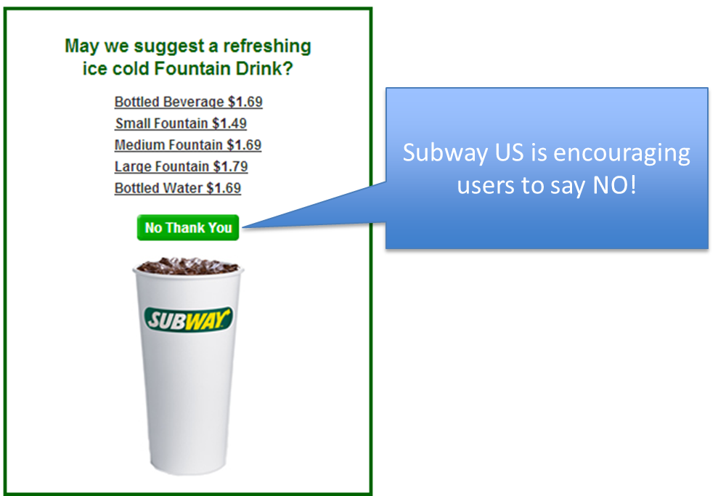

## Appealing Images

According to a 2012 Technomic study, 90 percent of consumers say that visual food appeal is an important or very important factor influencing fast casual food purchases. When customers order online, appealing images of your food help to stimulate the appetite. Take every opportunity to present pictures, and make sure that your food is presented in the best possible way with well-staged, well lit and consistent photographs.

### Dominos US Example

